SESSION : 2

Q1) : 1.
Create a Bugzilla account using your college or personal email, then log in and take a screenshot of your Bugzilla dashboard after successful login.

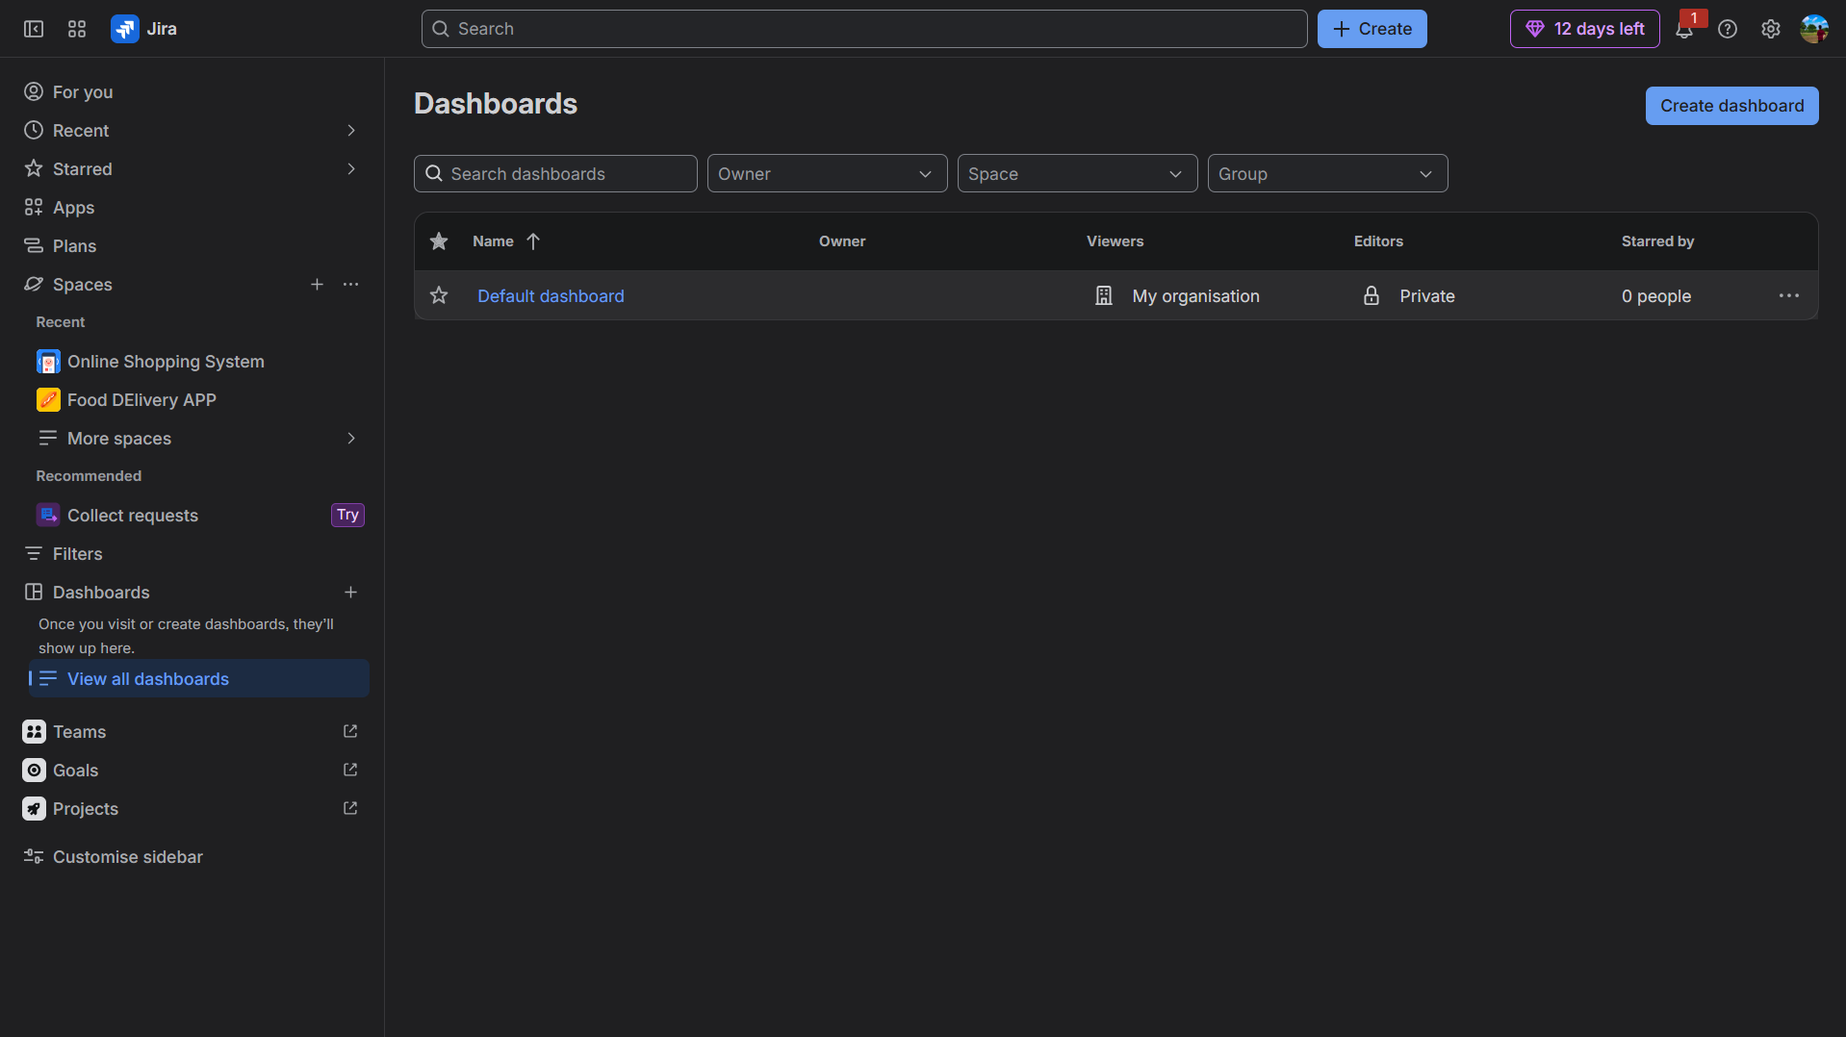

Q2) : 2.
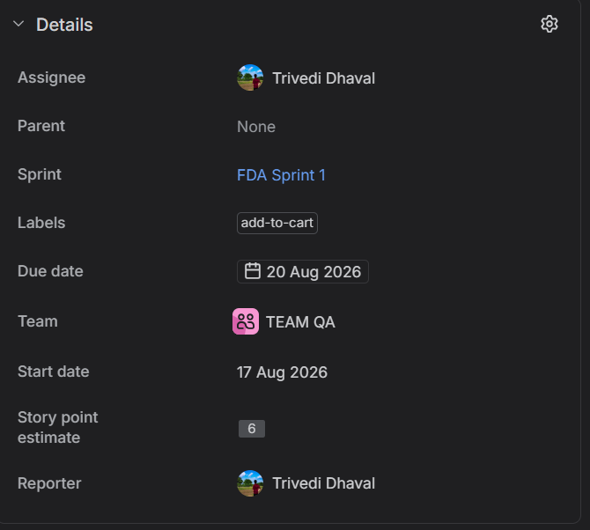
Pick any mobile app you use daily (such as Instagram, Zomato, or Paytm) and identify a real or imagined bug you have experienced — log this bug in Bugzilla with a clear summary, detailed steps to reproduce, expected vs actual result, and attach a screenshot or mock image showing the issue.

